# EXPERIMENT 1

**MOTOR CONTROL SYSTEM**

**OBJECTIVE**

**REFERENCE**

**EXPERIMENT EQUIPMENT**

**PRE-EXPERIMENT TASK**

**INTRODUCTION**

**The Components of the Motor Control System**

The Lab Exercises are completed with different types of motor for AC and DC. These can be loaded gradually with a magnetic powder brake. During the lab exercises studies are made of different control equipment that is used to run and control the motors. A few examples of control equipment are contactors, frequency converters, current rectifiers and PLC. These units are either assembled as a separate unit or as a module card that is fitted to the Base Unit 2000.

**Base Unit 2000**

The Base Unit is the centre for connecting different equipment. It is supplied by 230V AC and feeds the connected modules. These modules are inserted between two slides to a 64-pole socket.

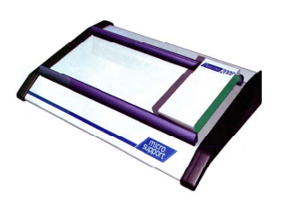

Figure 1 Base Unit 2000

**Vs Motor**

The Vs motor is a 250W synchronous motor. It is connected to 3phase 400V supply voltage and can be connected in Y or D. (Star or delta). The supply to the Vs motors power circuit is via a 3-phase terminal that is connected to the 3-phase network. It can also be supplied from a frequency converter.

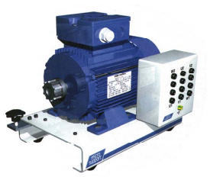

Figure 2 Vs Motor

**Ls Motor**

The Ls motor has a power of 250W and has a separately magnetised field winding. A current rectifier must be used when connecting to 230V AC, single phase.

Figure 3 Ls Motor

**Revolution Counter (rpm)**

To measure the rotation speed of the motor, a tachometer is attached to the motors axle.

Figure 4 Revolution Counter (rpm)

**3-Phase Terminal**

The connection of the Vs motor to 3-phase is via a 3-Phase Terminal having a 5 pole 16A plug according to standards CEE17. On the terminal there is a control panel for three phases and a neutral. The three phases are fused and fed via an isolating transformer. The terminal is prepared for current and voltage measurement on all phases. It has also a phase rotation indicator with LEDs showing the rotation. Connection to the 3-phase terminal is via lab leads, either direct or via the Contactor Module. Only touch protected 4mm lab sockets are used.

Figure 5 3 Phase Terminal

**Frequency Converter**

To be able to give a soft start and to regulate the speed, a frequency converter is used. This unit can be used for many other functions but in this exercise it is for soft start and stop, speed regulation and study of the overload protection.

Figure 6 Frequency Converter

**Current Rectifier Module**

The current rectifier is used to drive the DC motor. Different parameters are set such as speed, current limits, acceleration ramp etc.

Figure 7 Current Rectifier Module

**EXPERIMENT**

**E1. Motors Nameplate**

1. **Objective**

Objective: Before connecting up a motor it is important to know the mechanical

and electrical data. The mechanical data describes its size, axle diameter and

enclosure class. The electrical data describes connections, frequency, power

factor, rated current etc. The data found will now be explained.

1. **Operational Procedure**

Place the Vs motor on the workbench so that the nameplate is visible.

1. **Experimental Data**

Table 1 Experiment of Motors Nameplate

|  |  |
| --- | --- |
| **Type of Vs motor** | *Sh 71-4A (Squirrel Cage 3-Phase Synchronous Motor)* |
| **Frequency of Vs motor** | *50, 60 Hz* |
| **Voltage when motor is connected Delta (D)** | *220-240 V (50 Hz)* |
| **Voltage when motor is connected Star (Y)** | *380-420 V (50 Hz)*  *440-480 V (60 Hz)* |
| **Rated current in delta** | *1.5-1.6 A (50 Hz)* |
| **Rated current in star** | *0.85-0.93 A (50, 60 Hz)* |
| **Rating speed motor** | *1380 rpm (50 Hz), 1660 rpm (60 Hz)* |
| **Power factor** | *0.64* |
| **Slip (S)** | *1* |
| **IP rating** | *55* |

1. **Analysis and Experimental Task**
2. What is the stated axle power?

An axle is a rod or shaft that connects a rotor and load axel, then propel tangensial rotation and retain them into fixed axial position. In this experiment, the motor electromagnetic field applies the force to the axle which rotates the load.

Aside from transferring the motor power to the wheels, the axles hold the weight of the load as well as its additional brake force. Axles power deliver the driving power from the motor to the brake load.

1. What is the asynchronous speed of the motor?

The speed at which the rotor of the induction motor is rotating is called Asynchronous Speed. The rotor of the induction motor never rotates at the same speed as the stator rotating magnetic field. The speed of the rotor is always less than the synchronous speed.

Synchronous speed : $Ns=\frac{120f}{P}$

1. How many poles has this motor?

$$p=\frac{2.f.60}{n_{s}}=\frac{2.50.60}{1380}=4.3478$$

$$p=\frac{2.f.60}{n_{s}}=\frac{2.60.60}{1660}=4.3373$$

So, this motor has 4-5 poles

1. The relative slip s can be calculated by comparing **ns** with **na** = asynchronous speed. What is the percentage slip?

Slip refers to the difference between the shaft rotating speed (**na**) and the magnetic field's synchronous speed (**ns**), which is measured in frequency or RPM.

$$s=\frac{n_{s}-n_{a}}{n_{s}}×100\%$$

Because this motor is synchronous motor, the slip is 0

1. The power factor is given on the nameplate. What is the power factor of this motor?

Power Factor is the ratio of active power to total power (apparent power)

$$PF=\frac{Active Power}{Total Power}=\frac{P}{S}$$

P = Power consumed in the load (active power)

S = Total power of generator (or used)

**E2. Motors Direction of Rotation**

1. **Objective**

An electric motor can be started and stopped in many different ways. It will be necessary to run the motor in different direction of rotation. These problems will be studied in this chapter.

1. **Operational Procedure**

**B.1 Connecting the Motor**

1. Place the Vs motor on the workbench so that the nameplate is visible.
2. Connect the motor in star.

Connect to the 3-phase terminal as shown in figure 2.1 below. i.e. L1-U1, L2-V2, L3-W3.

1. Start the motor using the switch on the 3-phase terminal.

Gambar xx 3-Phase terminal with star connected motor.

1. Switch off at the 3-phase terminal and study the direction of rotation when the
2. speed is slow enough to see how the axle is turning.
3. State the direction of rotation seen from the axle end of the motor

The direction of rotation is always from the axle end.

1. Switch off the supply and let the motor stop completely. Change over any two phases, start up the motor and check the direction of rotation.
2. Sketch the motors direction of rotation seen from the other end.
3. By changing over any two phases on an asynchronous motor the direction of rotation will be reversed. The direction of rotation is dependent on the order in which the phases L1, L2 and L3 are connected to the motor windings. The  
   phases have an angle difference of 120 degrees. This means that the motor windings are supplied in rotation. See figure 2.2.

As the phases come in the order L1, L2 and L3, then according to 2.2 the motor will turn clockwise. If two of the phases are changed then the supply order is changed and the direction of rotation will change to anti-clockwise.

**B.2 Phase Rotation Meter**

A phase rotation meter can be used when the motor is at full speed and it is  
difficult to see which direction it is turning. This meter gives an optical indication  
of direction.

A motor that is connected L1-U1, L2-V2 and L3-W3  
will rotate clockwise.

1. Switch off the supply to the 3-phase terminal.
2. Connect the Vs motor and phase rotation meter as shown in figure 2.3.

Gambar xx 3-Phase terminal with phase rotation meter and Vs motor.

1. Switch on the 3-phase terminal and check the phase rotation on the phase  
   rotation meter. Was it correct?
2. Check the motor rotation with different phase changes. Leave the phase rotation meter connected and change over the phases as shown in the table  
   below. Mark with rotation arrows the motors direction of rotation.
3. **Experimental Data**

|  |  |
| --- | --- |
| Motor connection | Direction of rotation |
| L1-U1L2-V1L3-W1 | Clockwise |
| L1-U1L2-W1L3-V1 | Counter-clockwise |
| L1-W1L2-U1L3-V1 | Clockwise |
| L1-V1L2-U1L3-W1 | Counter-clockwise |
| L1-V1L2-W1L3-U1 | Clockwise |
| L1-W1L2-V2L3-U3 | Counter-clockwise |

1. **Analysis and Experimental Task**
2. Why we connect L1-U1, L2-V2 and L3-W3? Determine type of connection!

Wye connection,

1. By changing any two phases to an asynchronous motor, the motor will change  
   direction of rotation. If the motor is connected and after changing any phases or supply order (L1, L2, L3)

Summary

The direction of rotation is dependent on the order in which the phases L1, L2, and L3 that supplied in rotation

**E3. Overload Protection**

1. **Objective**
2. **Operational Procedure**
3. **Experimeental Data**

Experiment overload protection bermasalah, Danfoss tidak mentrigger arus sebenarnya. (di skip)

**E4. Control of the Motor**

1. **Objective**

In this exercise a motor shall be manoeuvred forward, reverse and from two stations. By given time period, motor can be start or stop with interlock relay.

1. **Operational Procedure**

The first stage is to change the direction of rotation of the motor using a control circuit. Standards give the directions as *clockwise* or *anti-clockwise*. The terms *forward* and *reverse* are also used.

* + - 1. **Forward and Reverse Maneuvers Procedure**

Place the equipment on the laboratory bench.

Study the circuit diagram in figure 4.1

*Figure 4.1 Diagram with forward and reverse of motor*

1. *Power circuit b) Control circuit*

Switch off the supply to the 3-phase terminal.

Connect the control as shown in figure 4.1. Number the switches according to the control module and also give the connection number.

Test the connections ***without having the motor connected***.

Figure 4.2 Below shows a simplified diagram of how the motors power circuit is connected to the 3-phase terminal and contactor module. Connect the power circuit as shown in figure 4.1

*Figure 4.2 Diagram for the connections between the motor and contactor module.*

Connect the control circuit as shown in figure 4.1

Switch on the supply to the 3-phase terminal. Start the motor by pressing the pushbutton **FORWARD**.

Stop the motor by pressing the **STOP** button.

Make sure the motor is completely still.

Press the pushbutton **REVERSE**.

Stop the motor by pressing the **STOP** button.

Make sure the motor is completely still.

The objective of interlocking the hold-in contacts is to prevent contacts Q2 and Q3 from closing at the same time. This would cause a short circuit as the phases are crossed in the power circuit.

* + - 1. **Time Controlled Motor Procedure**

1. **Experimental Data**

**Forward and Reverse Maneuvers**

Sketch the direction of rotation and draw connecting phas in the figure below.

|  |  |  |
| --- | --- | --- |
| **Button pressed** | **Direction of rotation** | **Connecting Phase** |
| Forward | Shape  Description automatically generated  clockwise | **L1 U1**  **L2 U2**  **L3 U3** |
| Reverse | Shape  Description automatically generated  Anti-clockwise | **L1 U1**  **L2 U2**  **L3 U3** |

**asd**

1. **Analysis and Experimental Task**
2. Explain in your words what happens when pushbutton **REVERSE** is pressed to run the motor in anticlockwise direction.

If reverse button pressed, relay reverse will be energized, indicated by illuminating reverse lamp. This relay forms an interlocking OR gate connection (parallel to reverse start button) and a hold-in-contact to avoid current flows into forward relay. Latch circuit keeps current flowing into relay contact which in figure 4.1 connecting L1 L2 L3 into W1 V1 U1 as reverse rotation persisted without keeping start button pressed.

1. Which contactor was energized when pushbutton **FORWARD** was pressed?

Forward contact

1. What happens when pushbutton **REVERSE** is pressed?

Reverse contact

1. Which set of contacts is used to break the hold-in circuit?

Normally closed contact triggered by opposite direction relay coil. For example: reverse NC contact is opened when forward coil is active. Forward contact break or opened hold-in-contact in reverse circuit and vice versa. If the motor is run clockwise, a lock prevents the possibility of the motor being run in two directions at the same time. If this did happen then there would be a short circuit with a great strain on the motor and the load connected to the shaft. When contactor **Q3** is energised, the hold-in contacts in the lower hold-in circuit, are opened. It is then impossible for contactor **Q2** to be energised.

**E3. Time Controlled Motor**

Hal.28

1. **Objective**

The inclusion of timer control in motor circuits is quite common. It can for example, start or stop a production line after a certain time so that a carton can pass a sensor. In the next exercise a time-controlled circuit will be connected using a timer relay.

1. **Operational Procedure**
2. Switch off the supply to the Base Unit and 3-phase terminal
3. Complete the control circuit shown in figure.

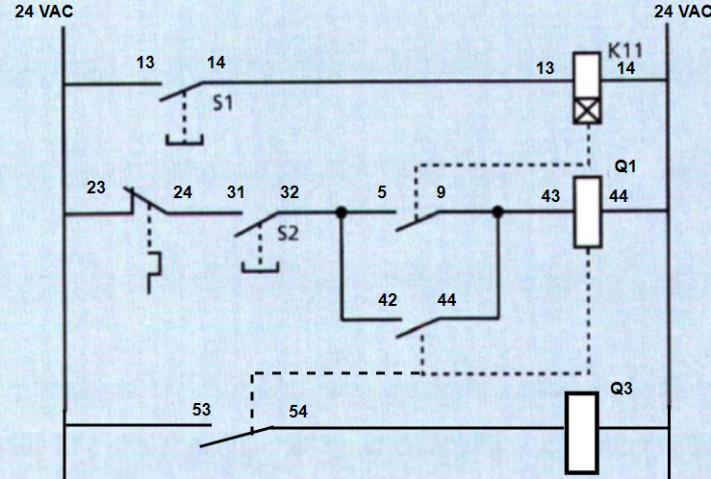

1. Set the timer relay to 5 seconds using the control knobs.
2. Switch on the supply to the equipment.
3. Press pushbutton S2.
4. Observe what happened.
5. Hold pushbutton S1 for 5 seconds, then hold S2.
6. Observe what happened.
7. Release S1, while holding S2.
8. Observe what happened.
9. Release both of pushbutton, then press S2
10. Observe what happened
11. Experimental Data

|  |  |
| --- | --- |
| What happened to the motor? | Description |
| After 5th procedure | (Ga Jalan) |
| After 7th procedure | (jalan) |
| After 9th procedure | jalan |
| After 11th procedure | jalan |

1. Analysis and Experimental Task
   1. What is the function of S1?

= sebagai input timer relay

* 1. What is the function of S2?

= u/ mengaktifkan interlocking pada Q1 setelah timer relay tertrigger dan untuk memulai pergerakan motor

* 1. Why do we have to hold S1?

= karena timer relay membutuhkan input yg konstan selama waktu yang ditentukan

* 1. How does the motor starts after S1 was released?

= motor start by pushing S2

**E3. Interlocking with Timer Relay**

Hal.30

1. **Objective**

To give another example of interlocking is when a motor must first be at full speed before a contactor for another task can be energised. Combining an interlock with a timer relay can solve this problem.

1. **Operational Procedure**
   1. Switch off the supply to the Base Unit and 3-phase terminal.
   2. Complete the control circuit shown in figure.

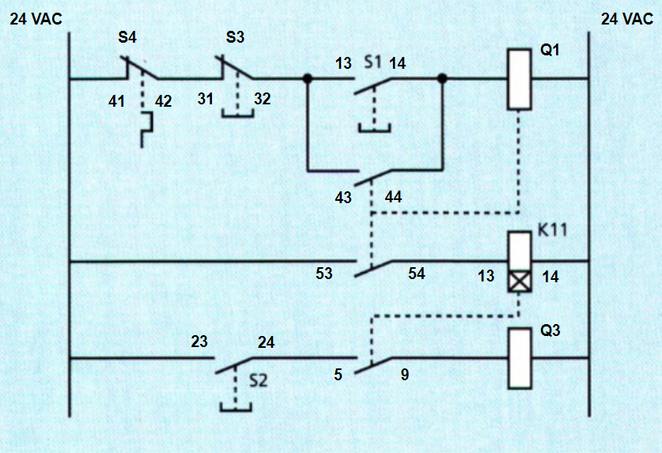

* 1. Set the timer relay 5 seconds.
  2. Press pushbutton S2.
  3. Observe what happened.
  4. Press pushbutton S1 and wait 5 seconds.
  5. Hold pushbutton S2.
  6. Observe what happened.

1. **Experimental Data**

|  |  |
| --- | --- |
| What happened to the motor? | Description |
| After 4th procedure | (Ga Jalan) |
| After 7th procedure | (Jalan) |

1. **Analysis and Experimental Task**
   1. What is the function of S1?

= trigger relay Q1, sehingga interlock (Q1) akan teraktivasi dan akan mentriger timer relay sehingga mentrigger relay Q3

* 1. What is the function of S2

= berfungsi u/ menyalakan motor setelah timer relay mencapai waktu yg ditentukan sehingga jika timer relay belum ditrigger/ blm mencapai waktu yg ditentukan maka saat S2 ditekan motor tidak akan menyala.

* 1. What happened after S1 was released?

= Interlock contact akan menutup dan Q1 akan tetap menyala

* 1. How does the motor starts after S1 was released?

= Dengan menunggu 5 detik dan menahan button S2

**E3. Motor Control with Frequency Converter**

Hal.40

1. **Objective**

An asynchronous motor’s speed can be controlled by giving an instruction in form of frequency. This can be done by the help of frequency converter. In this experiment, you will how to connect, configure, and control motor using frequency connector.

1. **Operational Procedure**

**B.1 Connecting The Motor**

1. Place the frequency conveter on the workbench.
2. Place the revolution counter and connect it to the motor axle. Tighten up the black fixing knobs.
3. Connect the motor in delta using jumpers on the connection box.

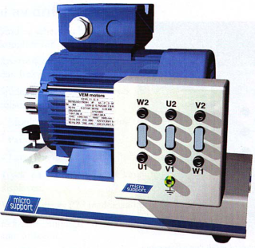

1. Connect the motor to the frequency converter as shown in figure.

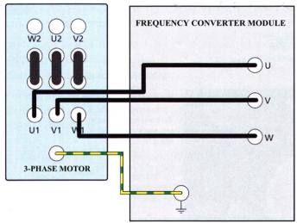

1. Connect 10A and GND port of avometer with frequency converter and asynchronous motor.
2. Set the avometer to measure AC Current.
3. Turn on the frequency converter.

**B.2 Configuring The Frequency Converter**

1. Examine the display. Press the **MODE** button and the three modes are displayed.
   * Monitor/frequency setting shows **0,0**
   * Parameter setting shows **P-0**
   * Alarm list shows **E—**

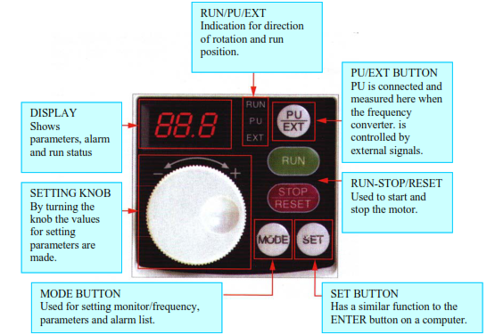

1. Press **PU/EXT** until **PU** indicator is light up.
2. Press **MODE** until parameter setting is displayed.
3. Select parameter **P1** using the setting knob.
4. Confirm by pressing **SET**. The maximum frequency stored displayed.
5. Set the maximum frequency value to 50Hz

**B.3 The Motors Dependency on Frequency**

1. Press **RUN** on the frequency converter.
2. Observe motor’s rotation value and current.
3. Press **STOP** on the frequency converter
4. Press **MODE** and set **P1** down to 40 Hz.
5. Repeat step 1 to 3.
6. Repeat the experiment for maximum frequency setting of 30Hz, 20Hz, and 10Hz
7. Reset **P1** to 50Hz. Disconnect the frequency converter’s connection to the motor.
8. **Experimental Data**

|  |  |  |
| --- | --- | --- |
| **Frequency (Hz)** | **Speed (rpm)** | **Motor Current** |
| **50** | **(1450)** | **(0.47)** |
| **40** | **(1100)** | **0.42** |
| **30** | **750** | **0.375** |
| **20** | **425** | **0.365** |
| **10** | **100** | **0.345** |

1. **Analysis and Experimental Task**
   1. How does the frequency converter replace wye/delta start?

= frequency converter dpt mengontrol set point, sehingga pd start motor dapat diatur inrush current yg kecil, yangmana hal ini memiliki fungsi yang sama dengan rangkaian wye. Setelah itu set point motor dpt dinaikkan sehingga dapat berjalan pada rangkaian delta dengan aman tanpa inrush current yg besar.

* 1. What is the relationship between speed and frequency?

= berbanding lurus n linier

* 1. What is the relationship between motor current and frequency?

= berbanding lurus

* 1. State which parameters of frequency converter were used for this task!

= P1 (Maximum Frequency Parameter)

**E5. Control of The Round Measuring Table**

1. **Objective**

Hal.58

1. **Operational Procedure**

**B.1 Connecting The Round Measuring Table**

* 1. Place the round measuring table and connect it to the revolution counter. Tighten up the black fixing knobs.
  2. Turn the motor axle manually and check that the axles are lined up

**E4. Motor Control with Current Rectifier**

1. **Objective**

Is to study an Is-motor and see how it reacts to different conditions. The motor has separately excited windings and is connected to the AC supply via a current rectifier on which various parameters can be set.

1. **Operational Procedure**

**B.1 Connecting The Motor**

* 1. Place the Ls motor on the workbench
  2. Turn the speed potentiometer all the way to the most counter clockwise position.
  3. Connect both current rectifier armature’s port to A1 and A2. Do not worry about the polarity.
  4. Connect both current rectifier’s field port to F1 and F2. Do not worry about the polarity.
  5. Connect current rectifier’s ground port with motor’s ground port.
  6. Place the revolution counter and connect it to the motor axle. Tighten up the black fixing knobs.
  7. Turn on the current rectifier

**B.1 Experiment**

* 1. Set the speed potentiometer to mid position.
  2. Observe motor’s speed and direction.
  3. Turn off the current rectifier.
  4. Reverse A1 and A2 connection
  5. Turn the speed potentiometer all the way to the most counter clockwise position.
  6. Turn on the current rectifier
  7. Set the speed potentiometer to mid position.
  8. Observe motor’s speed and direction.
  9. Turn off the current rectifier.
  10. Reverse F1 and F2 connection
  11. Turn the speed potentiometer all the way to the most counter clockwise position.
  12. Turn on the current rectifier
  13. Set the speed potentiometer to mid position.
  14. Observe motor’s speed and direction.
  15. Turn off the current rectifier. Disconnect its connection.

1. **Experimental Data**

|  |  |  |
| --- | --- | --- |
| **Connection** | **Direction of Rotation** | **Speed at mid position** |
| Top Armature– A1  Bottom Armature– A2  Top Field– F1  Bottom Field– F2 | (CCW) | … rpm |
| Top Armature– A2  Bottom Armature– A1  Top Field– F1  Bottom Field – F2 | (CW) |  |
| Top Armature– A2  Bottom Armature– A1  Top Field– F2  Bottom Field – F1 | (CCW) |  |

1. **Analysis and Experimental Task**
   1. How do you change the direction of the motor?

= By changing the polarity of armature connection or field connection

* 1. Based on the experiment draw the motor internal connection diagram corresponds to direction of rotation which includes its filed winding and armature winding!

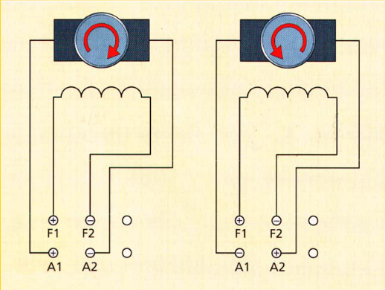

**EXPERIMENT 2**

**ELECTRO-PNEUMATIC CONTROL**

**OBJECTIVE**

Fluid Power takes an important role as a technology in the performance of mechanical work. Industrial field nowadays turn their sight to these mechanism because of many advantages despite of its disadvantages. It is important for engineering student to learn and understand about this concept, so they know what to do in real system.

**REFERENCE**

Anonymous. Pneumatics Control Technology-Chungpa EMT. 2011.

Peter Crosser and Frank Ebel. Pneumatics Basic-Level. 2007

**EQUIPMENT REQUIRED**

PN-7050 Air Service Unit 1 piece

PN-7051 Air distributer 1 piece

PN-7100 3/2-way valve with push button (N.C) 1 piece

PN-7101 3/2-way valve with push button (N.O) 1 piece

PN-7400 Pneumatic single-acting cylinder 1 piece

PN-7602 3/2-Way Single Solenoid Valve(N.C) 1 piece

PN-7610 5/2-Way Double Solenoid Valve 1 piece

PN-7402 Double Acting Cylinder with Air Cushion 1 piece

PN-7570 Electrical Limit Switch module(Left) 1 piece

PN-7570 Electrical Limit Switch module(Right) 1 piece

PN-7302 Different pressure valve (AND) 1 piece

PN-7301 Shuttle valve (OR) 1 piece

PN-7400 Pneumatic single-acting cylinder 1 piece

- Power Supply Module 1 piece

- Switch Module 1 piece

- Relay Module 1 piece

- Compressor 1 piece

- Pneumatic Hose Sufficiently

- Electrical leads Sufficiently

**PRE-EXPERIMENT TASK**

1. What is the difference of Pneumatic and Hydraulic system?
2. Why do we need the valves in that System? Explain briefly!
3. How do the 3/2-way valve and 5/2-way valve works?

**INTRODUCTION**

A pneumatic system is a system that uses compressed air to transmit and control energy. The principles of pneumatics are the same as those for hydraulics, but pneumatics transmits power using a gas instead of a liquid. Compressed air is usually used, but nitrogen or other inert gases can be used for special applications. With pneumatics, air is usually pumped into a receiver using a compressor. The receiver holds a large volume of compressed air to be used by the pneumatic system as needed. Atmospheric air contains airborne dirt, water vapor, and other contaminants, so filters and air dryers are often used in pneumatic systems to keep compressed air clean and dry, which improve reliability and service life of the components and system. Pneumatic systems also use a variety of valves for controlling direction, pressure, and speed of actuators.

Most pneumatic systems operate at pressures of about 100 psi or less. Because of the lower pressure, cylinders and other actuators must be sized larger than their hydraulic counterparts to apply an equivalent force. For example, a hydraulic cylinder with a 2 in. diameter piston (3.14 sq. in. area) and fluid pressure of 1,000 psi can push with 3140 lbs. of force. A pneumatic cylinder using 100 psi air would need a bore of almost 6½ in. (33 sq. in.) to develop the same force. Even though pneumatic systems usually operate at much lower pressure than hydraulic systems do, **pneumatics holds many advantages that make it more suitable for many applications.** Because pneumatic pressures are lower, components can be made of thinner and lighter weight materials, such as aluminum and engineered plastics, whereas hydraulic components are generally made of steel and ductile or cast iron. Hydraulic systems are often considered rigid, whereas pneumatic systems usually offer some cushioning, or “give.” Pneumatic systems are generally simpler because air can be exhausted to the atmosphere, whereas hydraulic fluid usually is routed back to a fluid reservoir.

**Pneumatics also holds advantages over electromechanical power transmission methods.** Electric motors are often limited by heat generation. Heat generation is usually not a concern with pneumatic motors because the stream of compressed air running through them carries heat from them. Furthermore, because pneumatic components require no electricity, they don‟t need the bulky, heavy, and expensive explosion-proof enclosures required by electric motors. In fact, even without special enclosures, electric motors are substantially larger and heavier than pneumatic motors of equivalent power rating. Plus, if overloaded, pneumatic motors will simply stall and not use any power. Electric motors, on the other hand, can overheat and burn out if overloaded. Moreover, torque, force, and speed control with pneumatics often requires simple pressure- or flow-control valves, as opposed to more expensive and complex electrical drive controls. And as with hydraulics, pneumatic actuators can instantly reverse direction, whereas electromechanical components often rotate with high momentum, which can delay changes in direction.

**Factory automation is the largest sector for pneumatics technology**, which is widely used for manipulating products in manufacturing, processing, and packaging operations. **Pneumatics is also widely used in medical and food processing equipment**. Pneumatics is typically thought of as pick-and-place technology, where pneumatic components work in

**is much more.** Because compressed air can have a cushioning effect, it is often called on to provide a gentler touch than what hydraulics or electromechanical drives can usually provide. In many applications, pneumatics is used more for its ability to provide controlled pressing or squeezing as it is for fast and repetitive motion. Moreover, electronic controls can give pneumatic systems positioning accuracy comparable to that of hydraulic and electromechanical technologies.

|  |  |
| --- | --- |
| **1a. Automobile Production Lines** | **1b. Pneumatic system of an automatic machine** |

**Fig. 1(a,b) Common pneumatic systems used in the industrial sector**

Pneumatics is also widely used in chemical plants and refineries to actuate large valves. It‟s used on mobile equipment for transmitting power where hydraulics or electromechanical drives are less practical or not as convenient and in on-highway trucking for various vehicle functions. And of course, vacuum is used for lifting and moving work pieces and products. In fact, combining multiple vacuum cups into a single assembly allows lifting large and heavy objects. Following are the use of pneumatics in a variety of applications i.e. used in controlling train doors, automatic production lines, mechanical clamps, etc.

**Fluid power systems** consist of multiple components that work together or in sequence to perform some action or work. People well versed in fluid power circuit and system design may purchase individual components and assemble them into a fluid power system themselves. However, many fluid power systems are designed by distributors, consultants, and other fluid power professionals who may provide the system in whole or in part. The major components of any fluid power system include:

* **a pumping device** — a hydraulic pump or air compressor to provide fluid power to the system
* **fluid conductors** — tubing, hoses, fittings, manifolds and other components that distribute pressurized fluid throughout the system
* **valves** — devices that control fluid flow, pressure, starting, stopping and direction
* **Actuators** — cylinders, motors, rotary actuators, grippers, vacuum cups and other components that perform the end function of the fluid power system.
* **support components** — filters, heat exchangers, manifolds, hydraulic reservoirs, pneumatic mufflers, and other components that enable the fluid power system to operate more effectively.

Electronic sensors and switches are also incorporated into many of today‟s fluid power systems to provide a means for electronic controls to monitor operation of components. Diagnostic instruments are also used for measuring pressure, temperature and flow in assessing the condition of the system and for troubleshooting.

**EXPERIMENT**

**Experiment 1. Direct and Indirect Control**

Direct control of single acting cylinder using 3/2-way valve with push button.

1. **Operational Procedure**
2. Configure circuit in **Figure 1** for N.C circuit.
3. On the Air Service Unit, adjust the operating pressure in about 2-3 atm. Make sure to always check the pressure control valve in „open‟ or „closed‟ state.
4. Write initial condition of valve when it is depressed and released.
5. Whenever removing hose from device, make sure there isn‟t compressed air that flowing in the hose.
6. Configure circuit in **Figure 2** for N.O circuit.
7. Write initial condition of valve when it is depressed and released.

**EXPERIMENT 3**

**PROGRAMMABLE LOGIC CONTROLLER (PLC) – MITSHUBISHI**

**OBJECTIVE**

Understanding automation process in the industrial field is essential for an engineer. Engineering student have to be used to work and practice in industrial environment.therefore, they are ready with the real system. In this experiment, we will use PLC Mitshubishi

that shows basic automation command clearly and easy to understand. We would have introduced about basic instruction, counter, and timer.

**REFERENCE**

David W. Pessen, Industrial Automation: Circuit Design and Components, 2008.

**EQUIPMENT REQUIRED**

1. What kind of industries that use or apply PLC to their system? Why industries use them?
2. What is company that produces the PLC?

**PRE-EXPERIMENT TASK**

**INTRODUCTION**

**EXPERIMENT**

**EXPERIMENT 4 (Rayhan Haqi)**

**PROCESS CONTROL TRAINER (PCT-100)**